

USER MANUAL
(Ver. 2.5)

Indice

1 Gantt 3

2 WBS 5

3 Task Network 7

4 Report 9

1 Gantt

A Gantt chart is a type of bar chart that illustrates a project schedule. Gantt charts illustrate the start and finish dates of the terminal elements and summary elements of a project. Gantt charts can be used to show current schedule status using percent-complete shadings and a vertical "TODAY" line as shown here.

There are two Gantt chart views in Mango. One from the Gantt tab in the Project View display, showing the individual project only. One from a tab on the Projects screen, showing a combined Gantt chart for all of the projects that are displayed via filter.

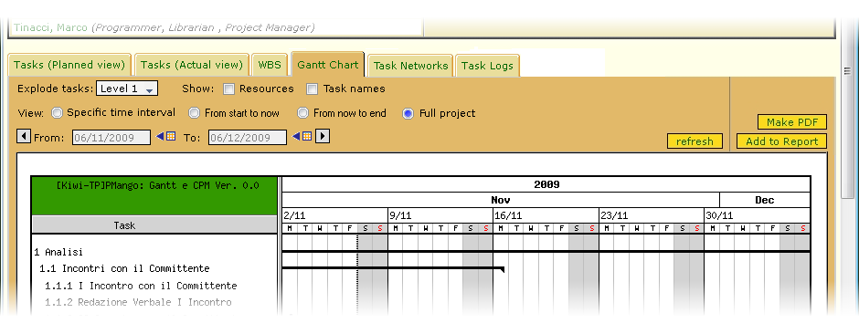

Each of the Gantt chart displays as a series of options available to user:

- “show task names”: when turned on, will show task names on the left column, next to task identifier. It will need to click on the submit button to effect the option, and so display change;

- “show resources”: when turned on, will show the string containing the list of the resources on the right margin of the chart. It will need to click on the submit button to effect the option, and so display change;

It’s also possible to choose the view of the Gantt chart:

- “whole project”: when selected, will show the Gantt chart from the project start date to the project finish date. It will need to click on the submit button to effect the option, and so display change;

- “start date to finish date”: when selected, it will possible to choose the start date and the finish date pushing the selection date buttons (*) and selecting the date. It will need to click on the submit button to effect the option, and so display change;

- “start date to now”: when selected, it will possible to choose the start date pushing the selection date button (*) and selecting the date; the finish date will be set to the current date. It will need to click on the submit button to effect the option, and so display change;

- “now to finish date”: when selected, it will possible to choose the finish date pushing the selection date button (*) and selecting the date; the start date will be set to the current date. It will need to click on the submit button to effect the option, and so display change;

The arrows are used to move the dates (From and To) backwards and forwards by one month at a time. This will automatically change the Gantt display to those dates;

It can be changed the time grain:

- hourly: if selected, time grain in Gantt chart will be hour by hour;

- daily: if selected, time grain in Gantt chart will be day by day;

- weekly: if selected, time grain in Gantt chart will be week by week;

- monthly: if selected, time grain in Gantt chart will be month by month;

- annually: if selected, time grain in Gantt chart will be year by year;

If the selected time grain is too fine for the Gantt chart, will be used the coarser one;

It’s also possible to choose the view of the WBS; using the image options, it can be adjusted the dimension of the image:

- fit the window: if selected, the dimension of the WBS image will fit the window;

- custom: if selected, the value of the width of the image will be set by the user;

- optimal: if selected, the dimension of the WBS image will be set to allow an optimal view of the whole image;

- default: if selected, the dimension of the WBS image will be set with default value (width 800 pixel);

2 WBS

A work breakdown structure (WBS) in project management and systems engineering, is a tool used to define and group a project's discrete work elements in a way that helps organize and define the total work scope of the project.

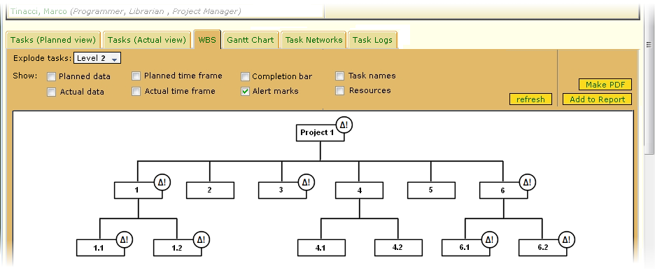

Each of the WBS displays as a series of options available to user:

- “show task names”: when turned on, will show task names on the left column, next to task identifier. It will need to click on the submit button to effect the option, and so display change;

- “show resources”: when turned on, will show a cell containing the list of the resources in all the task boxes. It will need to click on the submit button to effect the option, and so display change;

- “show alert marks”: when turned on, will show an alert mark symbol in every task box having nonconformity to planning/actual cost and planning/actual data. It will need to click on the submit button to effect the option, and so display change;

- “show planned data”: when turned on, will show a cell containing the planned data resources in all the task boxes. It will need to click on the submit button to effect the option, and so display change;

- “show actual data”: when turned on, will show a cell containing the actual data resources in all the task boxes. It will need to click on the submit button to effect the option, and so display change;

- “show planned time frame”: when turned on, will show a cell containing the planned start and finish date of the tasks in all the task boxes. It will need to click on the submit button to effect the option, and so display change;

- “show actual time frame”: when turned on, will show a cell containing the actual start and finish date of the tasks in all the task boxes. It will need to click on the submit button to effect the option, and so display change;

It’s also possible to choose the view of the WBS; using the image options, it can be adjusted the dimension of the image:

- fit the window: if selected, the dimension of the WBS image will fit the window;

- custom: if selected, the value of the width of the image will be set by the user;

- optimal: if selected, the dimension of the WBS image will be set to allow an optimal view of the whole image;

- default: if selected, the dimension of the WBS image will be set with default value (width 800 pixel);

3 Task Network

The Resource-Task Network (RTN) is a unified framework for the description and solution of a variety of process scheduling problems.

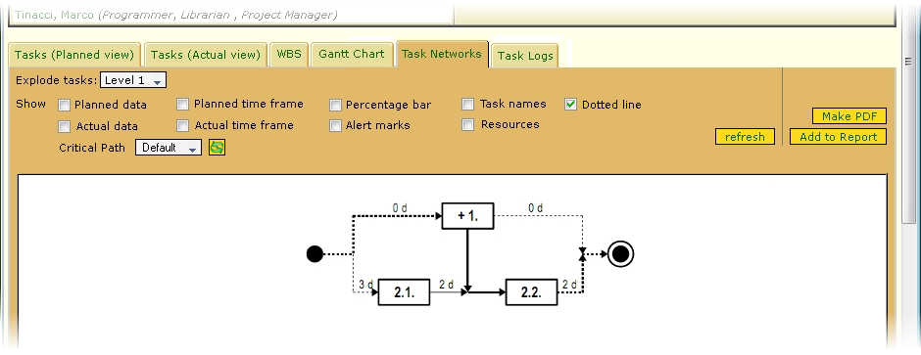

Each of the Task Network chart displays as a series of options available to user:

